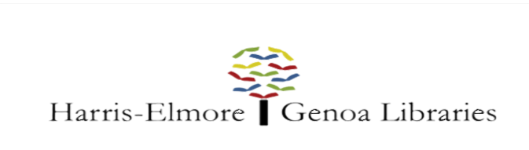 Custodian I

Classification | Custodian | FLSA Status | Non-Exempt
Level | Part Time | Division | Genoa Branch Library
Reports to | Director & Branch Manager | Schedule | 12 hrs/week
Salary Range | $11.50 hourly | Date Revised | February 2020

PRIMARY DUTIES
- Cleanliness and Sanitation of the library
- Minor maintenance and repair of the building and its contents or notification to the librarian of the need for repair or maintenance/supplies of the building and its contents
- The hours and duties of the custodian are flexible, but should be arranged to best serve the library; cleaning will not be performed during the library's public hours

EXAMPLES OF WORK

- Toilet bowls must be cleaned at least once a week/bathrooms each visit
- Sinks and drinking fountain must be cleaned three times a week
- Paper products/soap should be stocked as needed
- Carpets should be vacuumed each visit, including under any moveable furniture
- Spot treatment of stains (floors/furniture) as needed
- Tile in entry way, bathrooms, and hallway will be swept each visit and wet-mopped weekly
- All furniture, including bookshelves dusted weekly
- All hard surface areas wiped down each visit (every room)
- Trash and recycling bins will be emptied each visit
- Inside of front entrance doors and windows to the library and community room will be cleaned weekly
- Library windows will be cleaned inside quarterly
- Walls should be checked for spider webs or stains and dusted/wiped down periodically
- When necessary, clears snow and ice from entrances. Distributes rock salt/ice melt.

KNOWLEDGE & SKILLS

- Understands and follows written and oral instructions.
- Some knowledge of methods, materials, and equipment used in custodial work.
- Physical ability and stamina to perform required work
- Ability to establish and maintain effective working relationships with staff, other departments, and the general public.

EDUCATION/QUALIFICATIONS

- High School Diploma or GED Equivalent is required.
- Must have reliable transportation.
- One year cleaning experience preferred.

To apply, send a resume and three references to:

Ariel Gresh
Genoa Branch Library
genoamanager@harriselmorelibrary.org

Applicants will be accepted until the position is filled.

