Abbott BinaxNOW Rapid COVID-19 Antigen At-Home Test Kit

Patient Instructions for Use
TESTING METHOD 1 (preferred) – Smartphone or tablet

Requirements
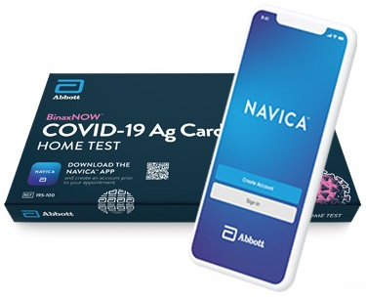
- Windows or Mac/Apple laptop with a webcam (or a desktop computer with an adjustable/moveable webcam), microphone, and speaker.
- An Apple phone/tablet or an Android phone/tablet.
- An email address.
- An internet connection.

Process

- Download the NAVICA app from the Apple App Store or the Google Play App Store from your smartphone/tablet.
- Open the NAVICA app on your smartphone/tablet.
- Create a NAVICA account from the app on your smartphone/tablet and remember your credentials (username and password). If the patient to be tested is a minor (age 17 or younger), tap the TEST SITE icon at the bottom of the NAVICA app and then tap the profile icon at the upper right of the screen to add a MANAGED PROFILE for the minor to be tested.
- Pick up a test kit from the library and take it home.
- Open a web browser (Chrome, Firefox, or Safari) on your laptop or desktop and go to ohio.emed.com
- Click the START TESTING button on the page.
- Click the LOGIN WITH NAVICA button on the page and use your NAVICA account credentials you created in Step 2 above.
- Confirm your account and personal information.
- Answer the series of questions to prepare for the visit with the eMed proctor and click CONTINUE. This will begin the testing session with the eMed proctor.
- Provide your name and date of birth to the eMed proctor.
- Follow all directions from the eMed proctor to take the test.

Results

- After you complete the test you will receive a “pass” on your NAVICA smartphone/tablet app that contains your test results. Tap PASS on the NAVICA app to view your results and pass.
- If you test negative, you can show your pass to your school or employer from your smartphone/tablet. Your school or employer will verify the validity of this pass using the NAVICA app on their own smartphone/tablet by scanning the patient’s QR code as displayed on their smartphone/tablet. Make sure your school or employer can view you actually opening the NAVICA app and accessing the pass in real-time.

Helpful Hints

- The eMed proctor is not a healthcare provider but is qualified to administer the test and read the results.
- Ensure that you have plenty of space in front of you to use the test kit. The test card must lay flat on a hard surface.
- The eMed proctor will have you adjust your webcam at various times during the testing. You must have a webcam that can be moved (laptop webcams work great – if you have a desktop webcam it needs to be repositionable). The proctor will need to view the test kit on the surface in front of you at certain times and will need to view you (the patient) at other times. For the test to be valid, follow all of the proctor’s instructions. For example, the proctor must be able to view the test card during the 15 minutes the test runs or it will be invalidated.
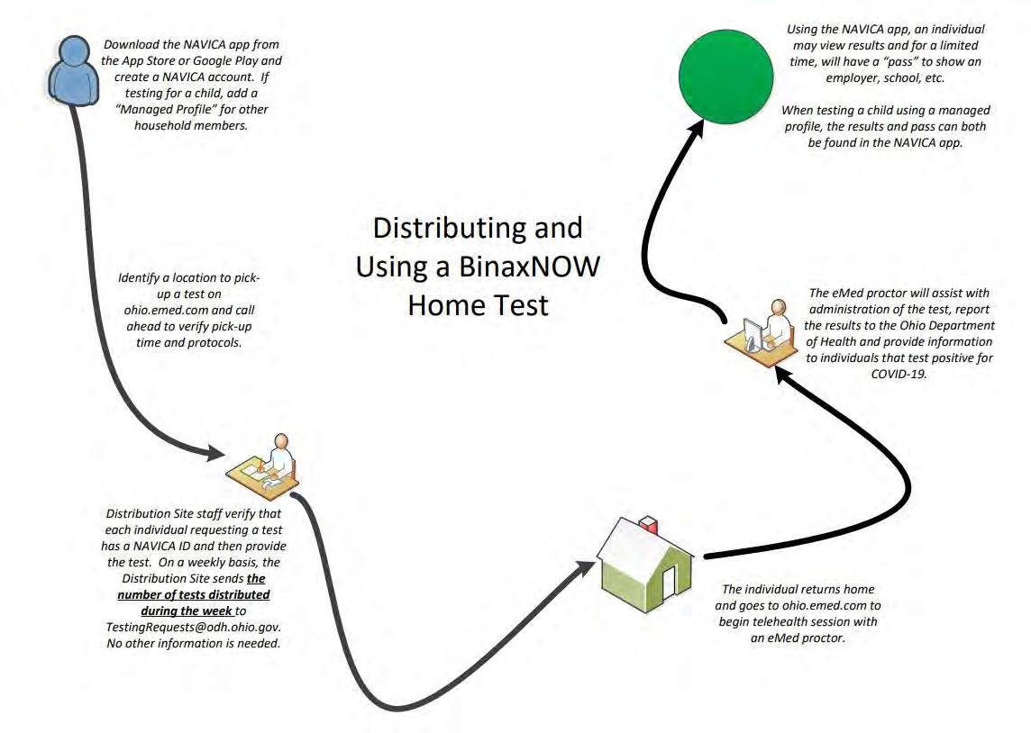
- You will need to scan the QR code on the test card with your webcam at two separate times. Make sure you hold the QR code up to the webcam when instructed. Keep the QR code in the center of the camera and hold it as still as possible.

Requirements
TESTING METHOD 2 – Computer or laptop with webcam
- Windows or Mac/Apple laptop with a webcam (or a desktop computer with an adjustable/moveable webcam), microphone, and speaker.
- An email address
- An internet connection.

Process
- Take the test kit home.
- Open a web browser (Chrome, Firefox, or Safari) on your laptop or desktop and go to ohio.emed.com
- Click the START TESTING button on the page.
- Click the CREATE NAVICA ACCOUNT button on the page.
- Create a NAVICA account and remember your credentials (username and password).
- Click the LOGIN WITH NAVICA button on the page and use your NAVICA account credentials you created in Step 6 above.
- Confirm your account and personal information.
- Answer the series of questions to prepare for the visit with the eMed proctor and click CONTINUE. This will begin the testing session with the eMed proctor.
- Provide your name and date of birth to the eMed proctor.
- Follow all directions from the eMed proctor to take the test.

Results
- If you do not have a smartphone/tablet and the NAVICA app, you can contact eMed for alternative results delivery at (844) 943-0753.

Helpful Hints
- The eMed proctor is not a healthcare provider but is qualified to administer the test and read the results.
- Ensure that you have plenty of space in front of you to use the test kit. The test card must lay flat on a hard surface.
- The eMed proctor will have you adjust your webcam at various times during the testing. You must have a webcam that can be moved (laptop webcams work great – if you have a desktop webcam it needs to be repositionable). The proctor will need to view the test kit on the surface in front of you at certain times and will need to view you (the patient) at other times. For the test to be valid, follow all of the proctor’s instructions. For example, the proctor must be able to view the test card during the 15 minutes the test runs or it will be invalidated.
- You will need to scan the QR code on the test card with your webcam at two separate times. Make sure you hold the QR code up to the webcam when instructed. Keep the QR code in the center of the camera and hold it as still as possible.

Frequently Asked Questions

What should an individual do if their telehealth session is interrupted before completion?
If a telehealth session is interrupted, the individual should immediately return to ohio.emed.com and select the option to begin a test and explain to a proctor that the prior session was interrupted. If the proctor determines that the session is unable to proceed, contact eMed support at (844)-943-0753 for assistance.

How are results reported?
eMed is responsible for reporting results. For the individual being tested, results are returned through the NAVICA app, and the NAVICA pass can be used to demonstrate a test result to an employer, school, or other party. For public health reporting, eMed sends results through the electronic lab reporting system.

Can we skip the telehealth portion of the test and just have the distribution site also perform the test?
No, the Home test’s Emergency Use Authorization from the FDA specifically states, “The BinaxNOW COVID-19 Ag Card Home Test is to be performed only with the supervision of a telehealth proctor.” Bypassing the telehealth portion of the test would also mean there would not be a prescription for the test to be administered, as the prescription specifically includes this aspect of the test. However, there are more appropriate, rapid antigen tests that can be administered at a distribution site that has a CLIA certification or waiver, can provide an order for the test, trained medical staff to administer and a mechanism for reporting the results of the test to the Ohio Department of Health.

